**Instructions for use of RasterModel.R**

Program prepared for Dr. Amy Hurtford, Memorial University of Newfoundland, by Kevin Bell as part of the MUCEP program.

The program required R packages rgdal and raster to operate. Its purpose is to take shapefile exported from the government of Canada’s GeoGratis website and convert them into raster files. A probability distribution is then calculated and overlaid on top of the original raster map. The coordinates and cell values of the combined raster file is then exported as a .CSV file and plotted using R base function.

Instructions for use:

1. Go to <https://www.nrcan.gc.ca/earth-sciences/geography/topographic-information/free-data-geogratis/11042> and click on the “Geospatial Data Extraction” link
2. Click on the “Select clipping area”

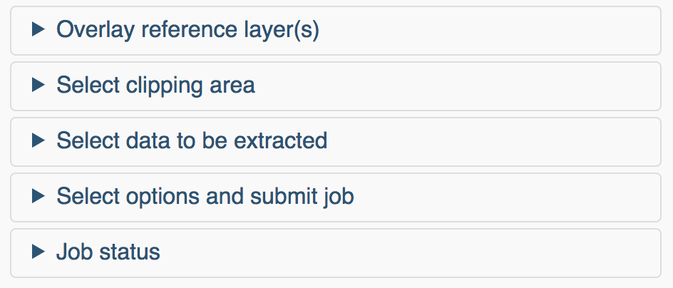

1. Then select “Custom Clipping Area”

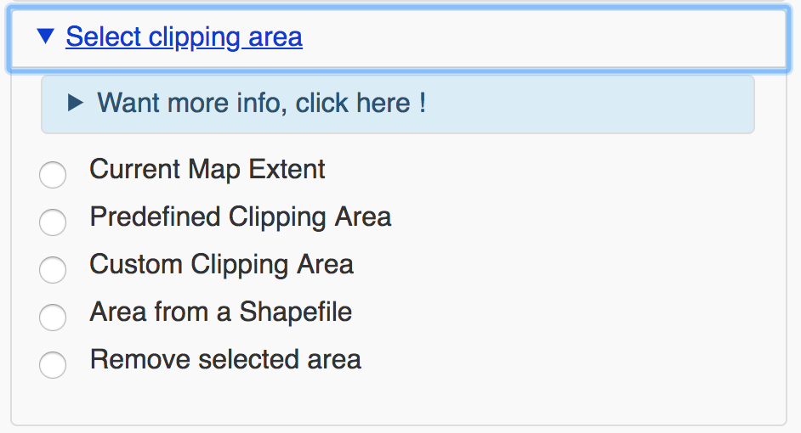

1. From here you can drag a rectangle over the area to be included in the shapefile

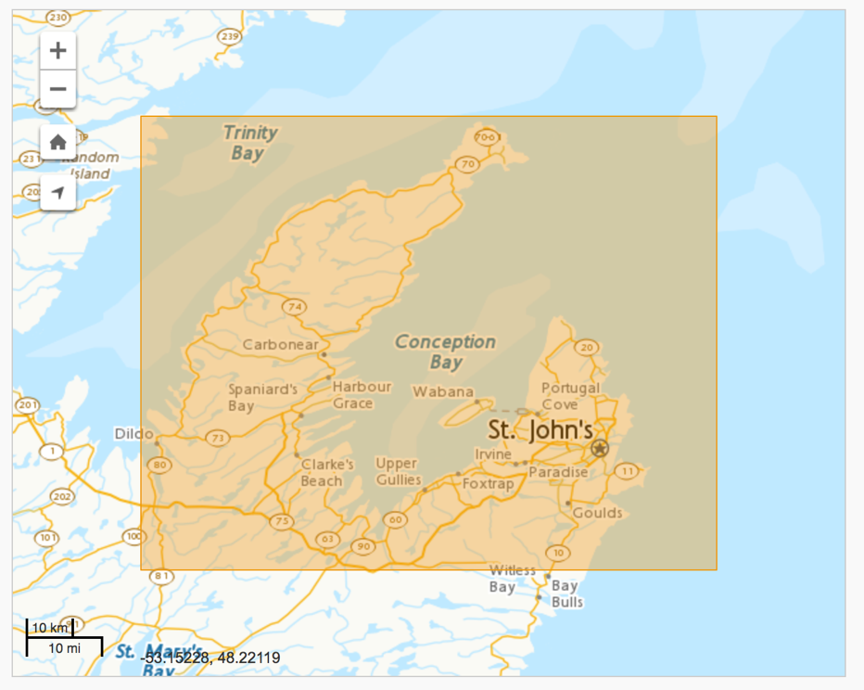

1. Then select the following options and add your email

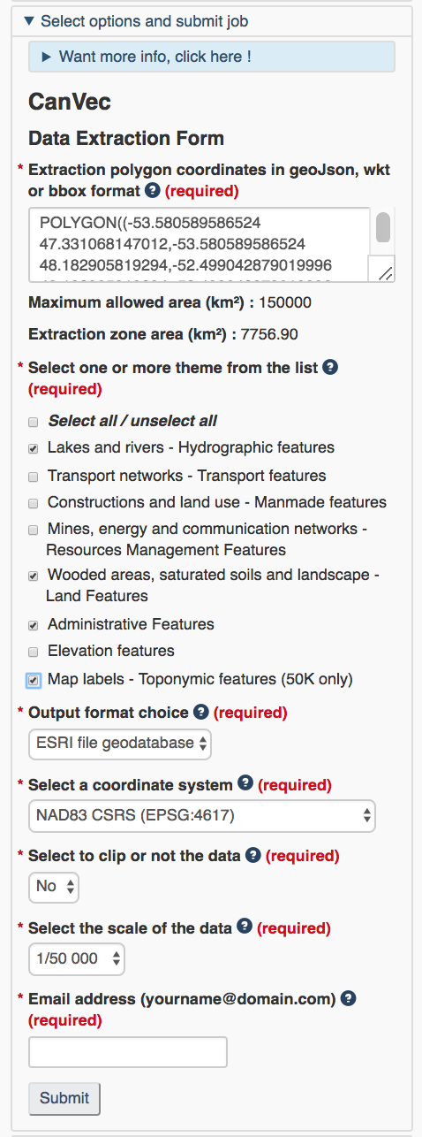

1. An email will be sent to you with a link to the shapefile download URL. Open this link and unzip the file that is downloaded. Be sure to put the file in your working directory.
2. Open the R script and add the path to the shapefile to the dsn argument of the function in line 47 and the name “shoreline_1” to the layer argument

shp = readOGR(dsn="/Users/kevinbell/Desktop/School/R Coding/Practice Directory/Shoreline shp",layer="shoreline_1")

After these steps are completed the script will function. If you already have a raster file that you want to added the distribution to comment out lines 47 and 49 and be sure to name the raster: “rastermap”.